Dunlop Traction
The main use of Dunlop's traction is in the maintenance of reduction in supracondyar fractures of the humerus in children.
Dunlop Traction
- Supracondyar fractures in children
- Allows swollen elbow to settle
- Contraindicated in open fractures and skin defects
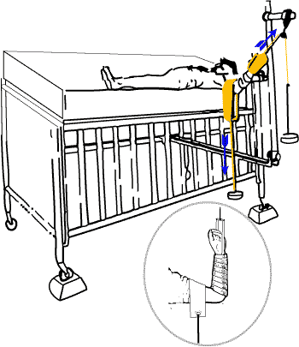
Skin traction is placed on the forearm and A special frame used on the side of the bed.
Traction is placed along the axis of the forearm as well as at right angles to the humerus by means of a broad sling placed around the upper arm. Bed blocks are required on the lateral side (fracture side up) of the bed.
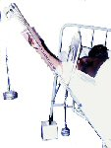
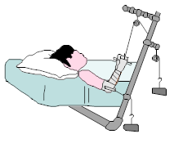
If a supracondyar fracture cannot be reduced to over 90 degrees elbow flexion, this method of traction is an alternative to invasive methods such as a percutaneous K-wires. It allows swelling to subside. Do not rely on this method to reduce a supra condylar fracture, a manipulation will still be required!

Pelvic traction for Backache
In sciatica and other backaches relief from pain can be obtained by means of pelvic traction. Traction is applied to a pelvic harness with weights over the end of the bed.
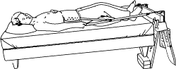
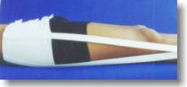
An alternative in Sciatica is the 90-90 position. By means of cushions under the knees, the hips are flexed near 90 degrees, as well as the knees. This shortens the sciatic nerve and relieves pain.

Acetabular Traction
In conservative treatment of acetabular fractures longitudinal traction in the long axis of the limb is often used. In addition the head of the femur can be disimpacted from the acetetabulum ( central fracture dislocations) by means of manipulation under anesthesia. The reduction is maintained by means of lateral traction from pins paced in intertrochanteric region.
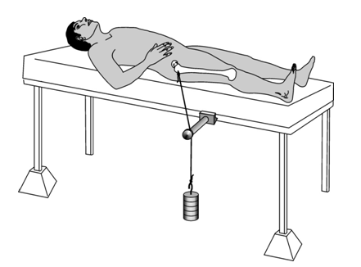
Lateral Traction for an acetabular fracture

